**Disabled Americans**

**FOR**

**SSI REFORM**

**NOW!**

**SSI REFORM**

**NOW!**



**See why so many Disabled Americans support Andrew Yang!**

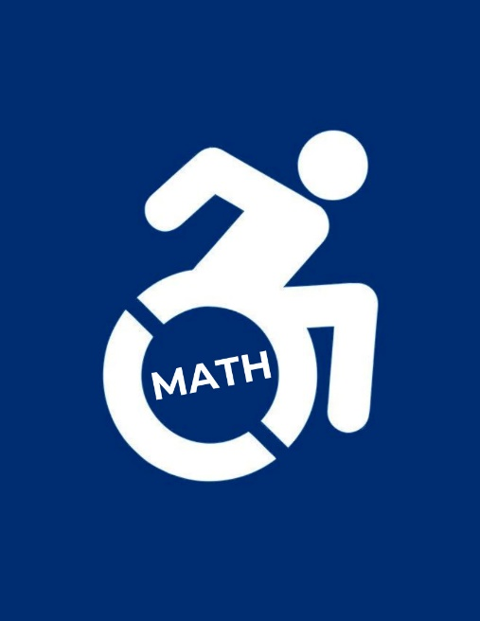**Did you know? Currently if you are disabled and on SSI you cannot:**

* **Save more than $2,000 in the bank**
* **Make more than $1,260 in any month**

**without risking losing benefits\***

*\*(CA min. wage @ 40 hours/week = $1,920)*

* **Keep more than half of what you earn**

**after $85 a month**

* **Make more than 2x your state's SSI**

**without automatically losing your**

**disabled status**

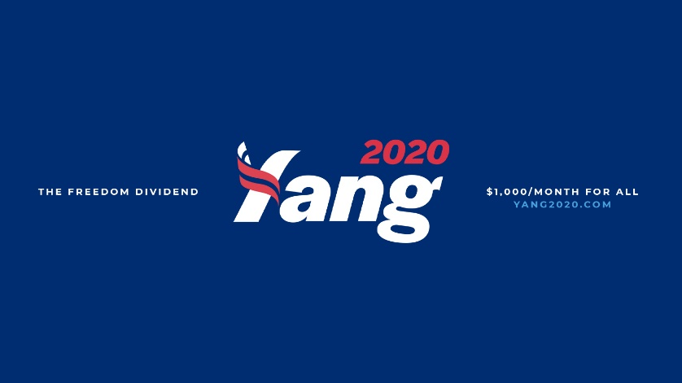**Yang's Freedom Dividend has no restrictions & can be given to you too!**

**The average wait time in getting SSI approval for being disabled is 4 months, and an appeal takes an average of 15 months! When the average American cannot afford an emergency $400 expense, we believe that's at least 4 months too long!**

**NO CHECK-UPS. NO APPEALS. NO BUREAUCRACY.**

**NO CONTEST.**

*Because being disabled is a medical condition, not a financial one.*